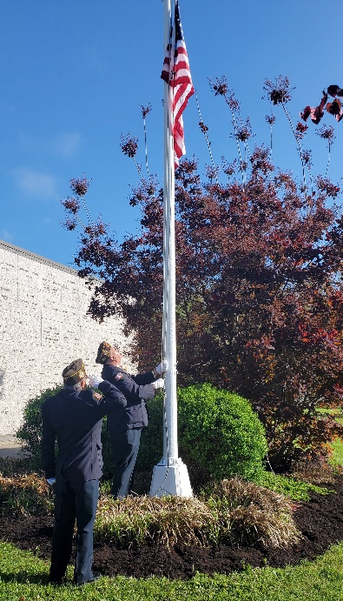
Monday, May 26, 2026 at 8:00 a.m.
Calvary Cemetery
636 Five Mile Drive, Ithaca
Join us for this solemn ceremony to commemorate the men and women who have given the ultimate sacrifice for their country. The Ithaca VFW Post 961 Color Guard, under the direction of Senior Vice-Commander Dan Weed and former Commander Roger Rumsey, will conduct this early morning ceremony outside the Queen of Peace Mausoleum.
The annual Memorial Mass* will be celebrated after the ceremony at 9:00 a.m. All veterans, families, and community members are welcome and encouraged to attend.
*In case of inclement weather, the Mass will be held at Immaculate Conception Church,
113 N. Geneva Street

